# Project Details

1. **Project - Evolent Health Test UI**

Technology used: Angular 6

Steps to Run the Project:

1. Open Project in Visual Studio code
2. Change Base Api URL in environment.ts file to access web api

**apiURL: 'http://localhost:53339/api/’**

1. Run **ng server** command in visual studio command
2. if you are facing any dependency issue please run **npm install** command

Add/Update Contacts

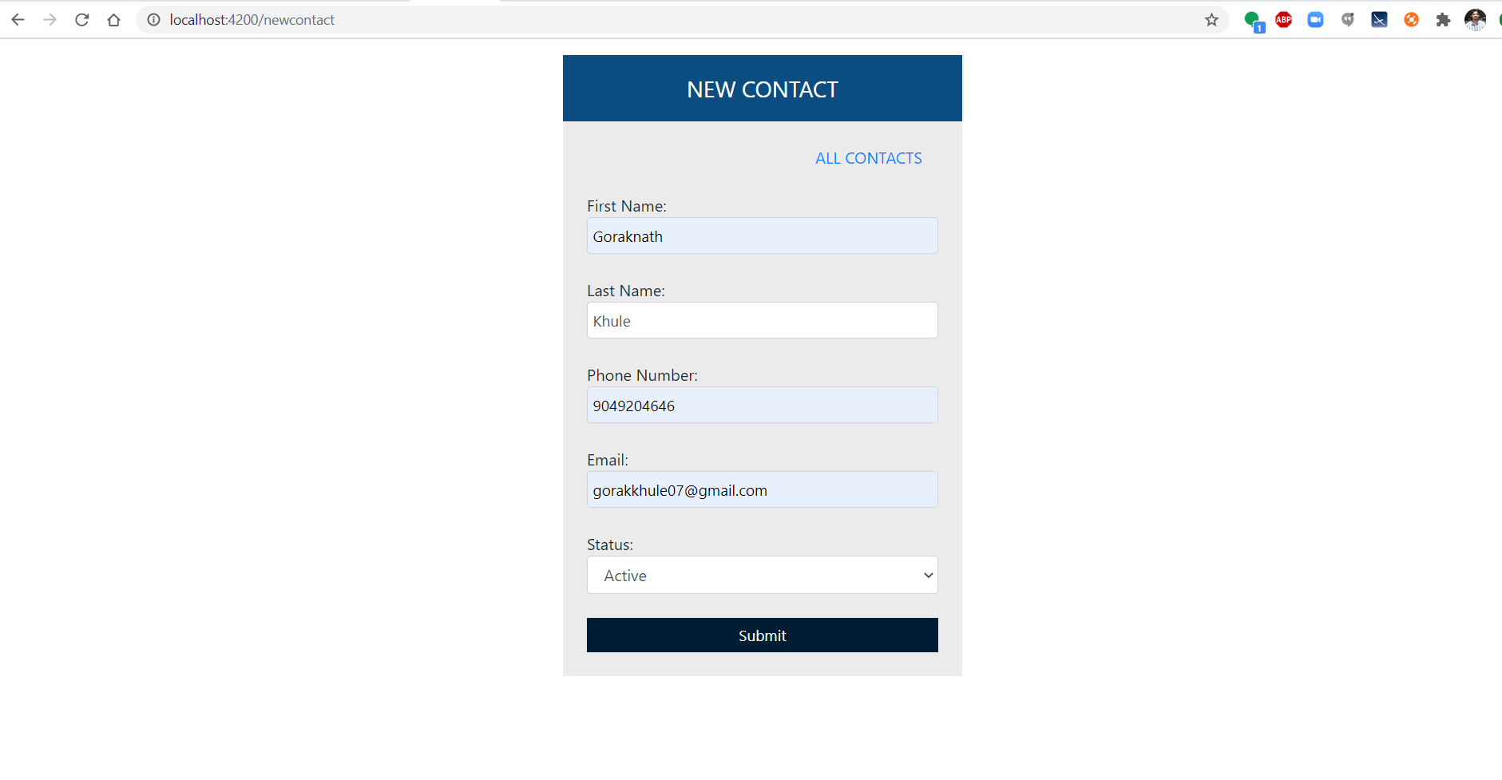

All Contacts

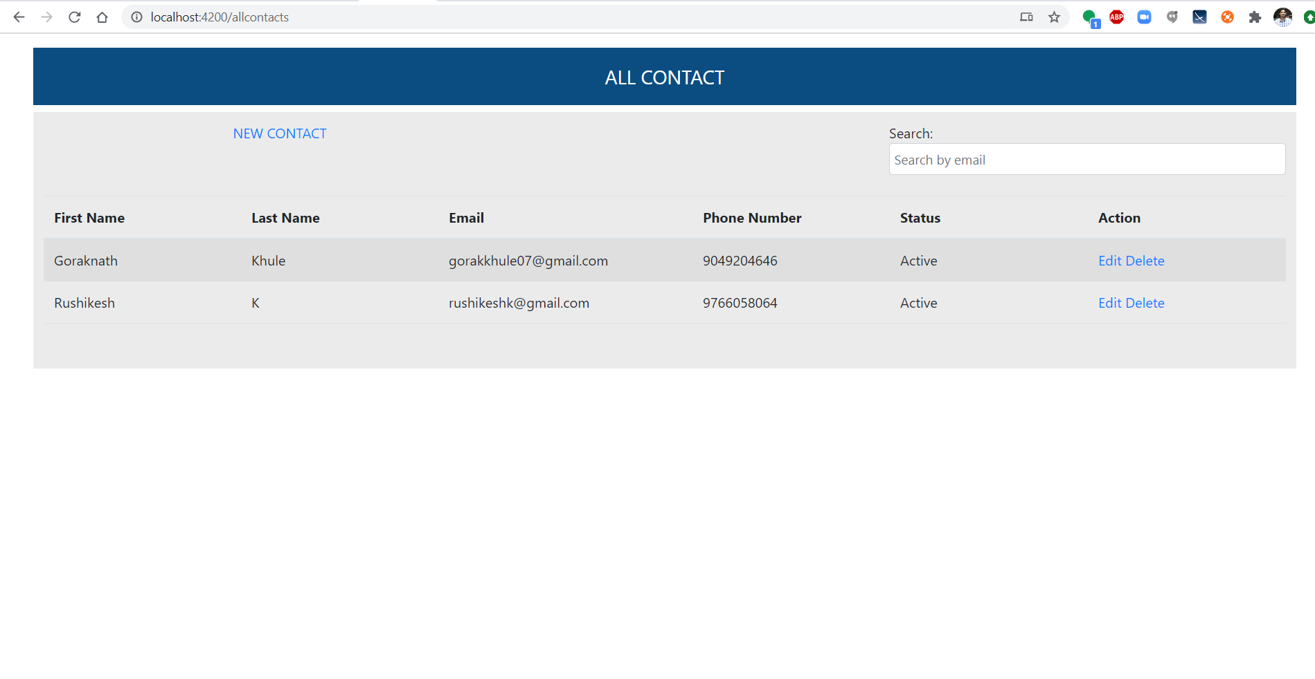

1. **Project – EvolentHelathTestApi**

Technology used: .NET core Web API 2.0

Testing Framework: Nunit

Database: MySql

**Steps to Run the Project:**

1. Open Project in Visual Studio both project will be open in same solution EvolentHelathTestApi & NunitTestEvolent.
2. Change database connection string in **Startup.cs** file
3. Run scripts form script file to create table and store procedures
4. Then build project and run from visual studio
5. Set same base api URL in angular project

**Default Output:**

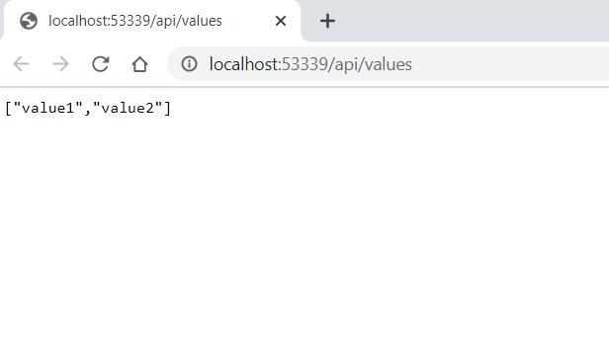

1. **Project – NunitTestEvolent**

**Technology Used: NUnit Framework**

**Steps to Run the Project:**

1. Build project from visual studio
2. Then open **Test Explorer** from **View** menu
3. Right click on **ContactControllerTest** and run test cases

**Result of test cases:**

